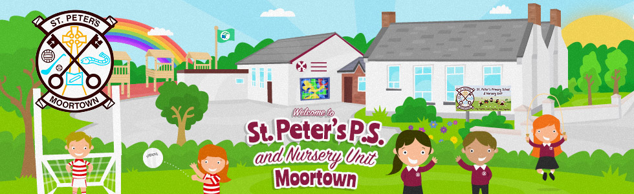

Dear Parents/Guardians,

World Book Day is on Thursday 7th March this year.

Dressing up
Children are invited to come to school in their favourite character costume or in their cosy pyjamas. Please ensure that your child is wearing sensible shoes, warm clothing and also brings a coat to school with them, as we will still be going outside for break and lunchtime as normal.

Book Swap
Children are invited to bring in at least one preloved book to school from Wednesday 28th February up until Wednesday 6th of March. This could be a book that your child/children may have loved but now no longer read. If you have additional books in good condition that you are willing to donate, we welcome them too. This will increase the variety of books from which the children will choose; any left-over books will be added to our school library or classroom libraries. We ask that donated books are in a fairly-good condition (for example, no missing pages or scribbles). We hope this will be a fantastic opportunity for your child/children to access some new and exciting reading material without any financial and environmental impact and helping our school become more eco-friendly. It will also encourage children to talk about their favourite stories and make recommendations to their friends.

Reading homework
On Thursday the 7th of March, children will only have reading homework to enjoy their new book from school that day.

Our World Book Day will be filled with lots more reading activities, treats and surprises for the children. Keep up an eye on the school website to see all our World Book Day fun!

Thank you for your continued support with your child/children’s learning.

