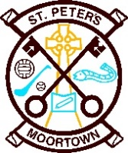
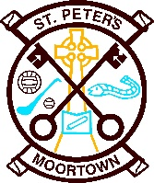
School Holidays 2022 - 23

26th Sept. - Staff Training Day
31st Oct – 4th Nov - Halloween Holidays
23rd Dec – 4th Jan - Christmas Holidays
13th - 17th Feb - Mid Term Break
17th Mar - St Patrick's Weekend
7th - 14th Apr - Easter Holidays
1st May - Bank Holiday
29th May – 2nd June - Mid Term Break

Please note the above holidays may be subject to change

