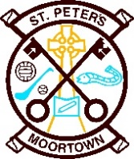
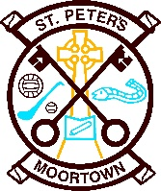
School Holidays 2021 - 22

27th Sept. - Staff Training Day
25th - 29th Oct. - Halloween Holidays
24th Dec - 4th Jan - Christmas Holidays
14th - 18th Feb - Mid Term Break
17th - 21st Mar - St Patrick's Weekend
15th - 22nd Apr - Easter Holidays
2nd May - Bank Holiday
30th May - 3rd June - Mid Term Break

Please note the above holidays may be subject to change

